13. Write the Python Program to Implement Minimax Algorithm for Gaming
Name:P.Gayathri
Reg.No:192424324

Aim
To implement the Minimax Algorithm for a two-player game, where one player (MAX) tries to maximize the score and the other player (MIN) tries to minimize the score.
Algorithm:
Step 1:
Define the game tree with terminal node values.
Step 2:
Start from the root node.
Step 3:
If it is MAX's turn, choose the maximum value among the child nodes.
Step 4:
If it is MIN's turn, choose the minimum value among the child nodes.
Step 5:
Repeat the process until reaching the leaf nodes.
Step 6:
Propagate the values back to the root.
Step 7:
Display the optimal value chosen by the Minimax algorithm.

PROGRAM:
# Minimax Algorithm for Gaming
# Tree Output

def minimax(depth, node, maximizing_player, values):

if depth == 3:
return values[node]

if maximizing_player:
return max(
minimax(depth + 1, node * 2, False, values),
minimax(depth + 1, node * 2 + 1, False, values)
)
else:
return min(
minimax(depth + 1, node * 2, True, values),
minimax(depth + 1, node * 2 + 1, True, values)
)

# Leaf node values
values = [3, 5, 2, 9, 12, 5, 23, 23]

# Calculate best value
best_value = minimax(0, 0, True, values)

# Display the game tree
print()
print(" MAX")
print(" / \\")
print(" MIN MIN")
print(" / \\ / \\")
print(" MAX MAX MAX MAX")
print(" / \\ / \\ / \\ / \\")
print(" 3 5 2 9 12 5 23 23")

print()
print("==============================")
print("MINIMAX ALGORITHM RESULT")
print("==============================")
print("Optimal Value =", best_value)
OUTPUT:
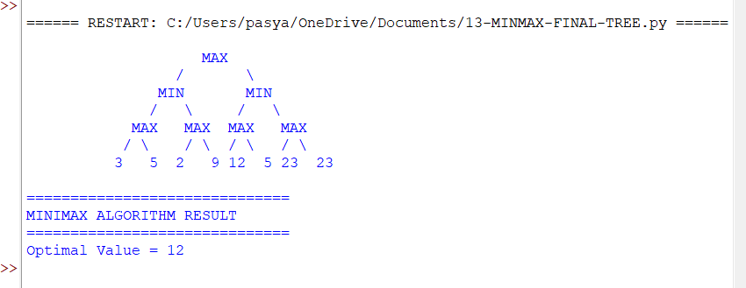

RESULT:
Thus, the Minimax Algorithm was implemented successfully in Python, and the optimal game value was found by evaluating all possible moves using the Minimax strategy.

